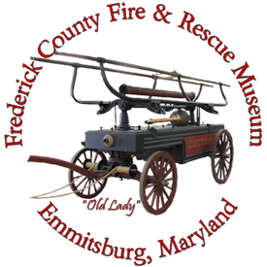
Box 382
300 South Seton Avenue
Emmitsburg, MD 21727

The Frederick County Fire & Rescue Museum will host an open house on Wednesday, March 27, 2024 from 6:30PM to 8:30PM at the museum located at 300B South Seton Av. In Emmitsburg just north of the National Fire Academy.

Several new items will be on display including the “Junior Defender” uniform manikin and the historic original “tin type’ of an actual “Junior Defender. Also on display from the Junior Fire Co. No. 2 that was just added last year is the restored Silsby hand drawn hose reel believed to be the original hose reel for the Juniors 1876 Silsby steam pumper, the first steam pumper in Frederick.

Additionally, the 1919 Ahrens-Fox originally purchased for the United Steam Fire Engine Co. No. 3 now owned by the Gladhill family is still on display.

The Frederick County Fire & Rescue Museum is always looking for new members to help maintain man the museum on weekends and for special openings during the week. The museum will open for the 2024 season on April 6, 2024 and will be open most weekends until the end of September open from 12-4 each Saturday and Sunday.

